



Mercury API Specification Processor – Payment Status Request
Inbound From Client

Table of Contents
Confidentiality Notice: This document contains private information about Mercury (Pty) Ltd. You can't copy, reproduce, or share its product details, intellectual property, or design methods with anyone else unless you have our written consent.

1) Document Purpose 3
2) Process Flow 4
3) Mercury Payment Status Request Message from Client 6
4) Embedded Participant Message Structures 18

Document Purpose
The purpose of this document is to provide a detailed specification of the Payment Status Request call to be received by the Mercury Processor API from the Client (Mercury Client) as part of the Mercury Credit Transfer Process.

This document will focus on the Inbound Message from the Mercury Client to the Mercury Processor API and will indicate the processing to be completed before constructing the Payment Status Request message to be sent to the Host (Enterprise or External).

NOTE: Some of the values contained in the Outgoing Message Structure will be retrieved from the Configuration Settings that are specific to the Mercury Processor API for the specified Entity.

Process Flow
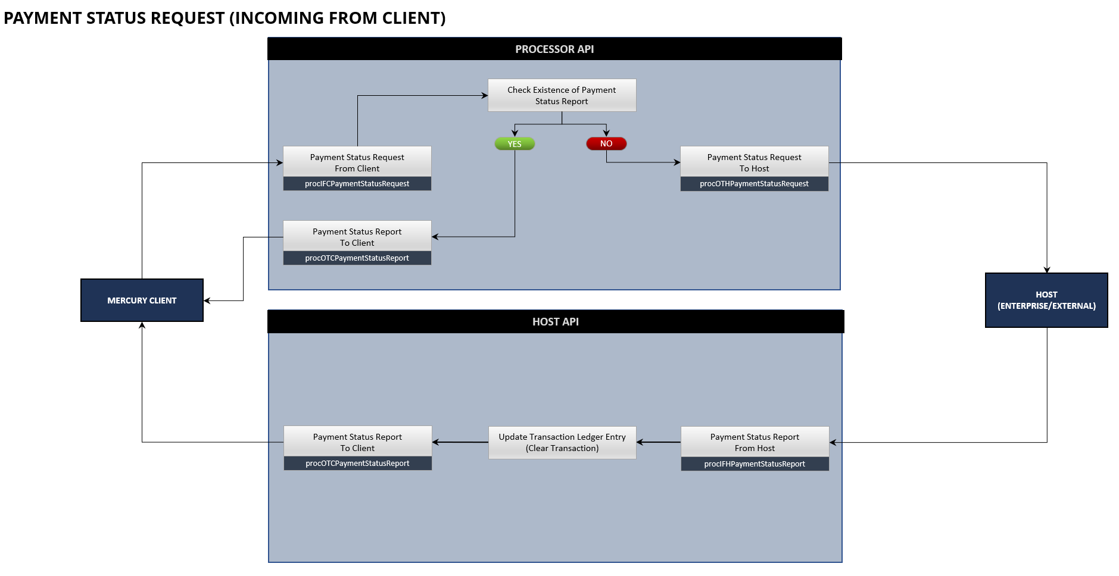
The Mercury Payment Status Request process flow indicated above is initiated on the Mercury Client (when a Payment Status Report for a Credit Transfer Request have not been received) and the request will be processed from the Mercury Client to the Mercury Processor API. After decryption and validation of the message by the Mercury Processor API, the Mercury System will check whether a Payment Status Report for the request already exists.

If a Payment Status Report for the Request is found, a Payment Status Report (Out to Client) message will be constructed and sent to the Mercury Client.

If a Payment Status Report for the Request is not found, a Payment Status Request (Out to Host) message will be constructed and sent to the Host (Enterprise or External).

The response to the Mercury Client will be based on the decryption and validation results and sent to the Mercury Client before proceeding with the process of validating whether an existing Payment Status Report exists for the request.

If the request to the Host (Enterprise or External) was successful (indicated by a 200 HTTP Response), the request will be processed by the Host (Enterprise or External).

The Host (Enterprise or External) will send the response (Payment Status Report), as a separate message (Not as a response to the original Payment Status Request) based on the result of the processing of the request. The Payment Status Report (In from Host) will be processed from the Host (Enterprise or External) to the Mercury Host API. After decryption and validation of the message by the Mercury Host API, the associated Transaction Ledger Entry will be Updated as Settled (Based on the Internal Mercury Reference) and then the Payment Status Report (Out to Client) message will be constructed and sent to the Mercury Client.

The response to the Host (Enterprise or External) will be based on the decryption and validation results and sent to the Host (Enterprise or External) before proceeding with the Transaction Ledger Entry Update, Out to Client Message construction and sending of the message to the Mercury Client.

Mercury Payment Status Request Message from Client

Overview
This Payment Status Request API is invoked during the processing of the Payment Status Request received from the Mercury Client.

Process Flow
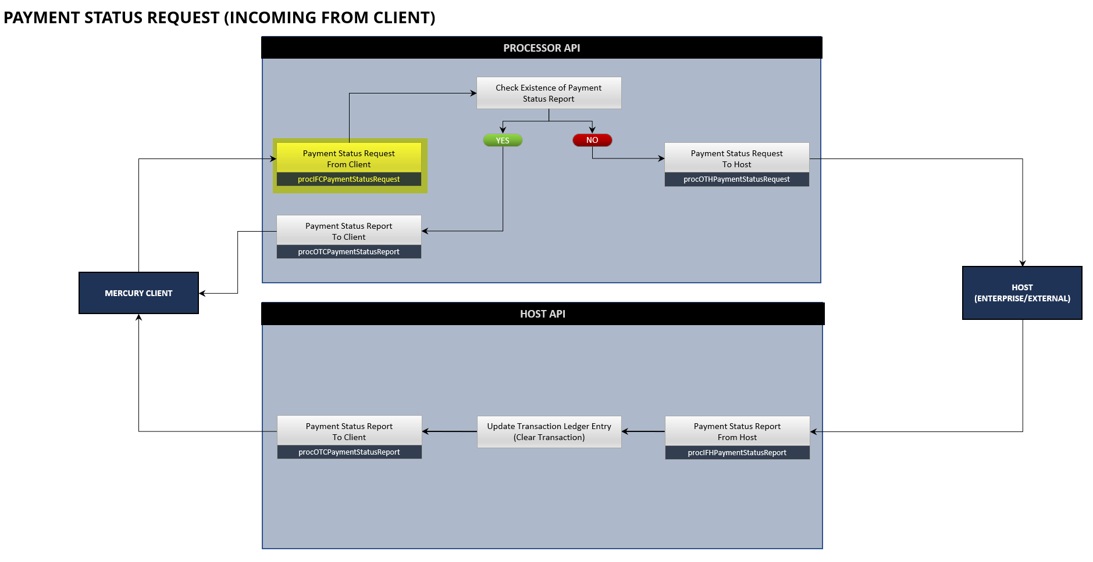
When receiving the Mercury Payment Status Request message from the Mercury Client for processing, the Mercury Processor API need to validate and respond to the Mercury Client, before validating the existence of the Payment Status Report on the Mercury System and then initiating a separate Mercury Payment Status Request from the Mercury Processor API to the relevant Host (Enterprise or External) if the Payment Status Report was not found, or initiating a separate Mercury Payment Status Report from the Mercury Processor API to the Mercury Client if the Payment Status Report was found.

As part of the basic API Processing the following steps need to be followed:

STEP | DESCRIPTION
1. | Store and Log the Message Request Details in the Message Request Detail table for auditing purposes.  Table Name: mrd_Message_Request_Detail
2. | Initialize the Payment Status Request (In From Client) Message Class with the details received in the API Call from the Mercury Client.  Message Class: procIFCPaymentStatusRequest
3. | Validate the Secure Token contained in the Message against the content of the Payment Status Request Message received from the Mercury Client.  Error Response Code: ECL8110006
4. | Complete the following basic validations on the Message Class  - Field Types  Validate if the values received in the message are of the correct type as specified by the Message Class Structure.  Error Response Code: ECL8110001  - Field Lengths  Validate if the values received conform to the field lengths specified by the Message Class Structure.  Error Response Code: ECL8110002  - Required Fields  Validate if all the required fields have been received as specified by the Message Class Structure.  Error Response Code: ECL8110004  - Duplicates  Validate that the message received is not a duplicate. Base validation on the following fields:  - Source Transaction Identifier  - Message Request Type  - Subscriber ID  - HTTP Response Code (200 cannot already exist)  Error Response Code: ECL8110021
5. | Complete the following custom validations on the Message Class  - Creation Date Time  Ensure that the Creation Date Time value received conforms to the structure specified in the Message Class Structure.  Error Response Code: ECL8110003  - Source Transaction Identifier  Validate if the Transaction Identifier value is unique for the specific Mercury Client.  Error Response Code: ECL8110021  - Original Message Identification  Validate if the Message Identification for the Original Credit Transfer Request can be found to match this value.  Error Response Code: ECL8110003  - Original UETR Structure  Validate if the Original UETR value conforms to the specification and structure of a UETR value.  Error Response Code: ECL8110003  - Subscriber ID  Validate if the Subscriber ID exist on the Client API Configuration Table.  Table Name: cac_Client_API_Configuration  Error Response Code: ECL8110022
6. | If any of the validations have failed, respond to the Mercury Client with the appropriate Error Response Code and description of the error detected.  Use the Message Request Response structure.  The details of the response to the Mercury Client should also be logged against the Entry that was added to the Message Request Detail table.
7. | If any of the validations have passed, respond to the Mercury Client with the appropriate Error Response Code (Success).  Use the Message Request Response structure.  The details of the response to the Mercury Client should also be logged against the Entry that was added to the Message Request Detail table.
8. | After responding to the Mercury Client, attempt to locate the Payment Status Report for the details received.
9.1 | If the Payment Status Report for the Payment Status Request could be located, proceed to construct the Payment Status Report (Out to Client) Message.  Message Class: procOTCPaymentStatusReport  NOTE:  The details of this Message Structure are contained in the Mercury – OTC – Payment Status Report specification document.
9.2 | Process the constructed Payment Status Report (Out to Client) Message to the Mercury Client.  NOTE: The details of the Payment Status Report (Out to Client) should be logged in the Message Request Detail Table.
10.1 | If the Payment Status Report for the Payment Status Request could NOT be located, proceed to construct the Payment Status Request (Out to Host) Message.  Message Class: procOTHPaymentStatusRequest  NOTE:  The details of this Message Structure are contained in the Mercury – OTH – Payment Status Request specification document.
10.2 | Process the Payment Status Request (Out to Operator) Message to the Operator (Bankserv).  NOTE: The details of the Payment Status Request (Out to Host) should be logged in the Message Request Detail Table.

Message Requirements
DEVELOPMENT
ENDPOINT | https://payments-test.azurefd.net/api/beapiGlobalMercuryClientProcessor
HEADERS | x-beapiglobalmercuryclientprocessor-api-version  1.0.0-dev  Ocp-Apim-Subscription-Key  TBC  environment  LIVE  subscriberID  TBC

STAGING
ENDPOINT | https://payments-test.azurefd.net/api/beapiGlobalMercuryClientProcessor
HEADERS | x-beapiglobalmercuryclientprocessor-api-version  1.0.0-staging  Ocp-Apim-Subscription-Key  TBC  environment  LIVE  subscriberID  TBC

PRODUCTION
ENDPOINT | https://dt-apim-zan-prod-paymenthub.directtransact.co.za/api/beapiGlobalMercuryClientProcessor
HEADERS | x-beapiglobalmercuryclientprocessor-api-version  1.0.0  Ocp-Apim-Subscription-Key  TBC  environment  LIVE  subscriberID  TBC

Request
REQUEST DETAIL
ENDPOINT | {Processor Endpoint}/procIFCPaymentStatusRequest
METHOD | POST

REQUEST BODY
CLASS NAME | clsIFCPaymentStatusRequest
FIELD | DESCRIPTION
secureToken | Required  Unique encrypted value constructed from the field values contained in the message.  Format:  String
subscriberID | Required  Unique Subscriber ID that is issued by the Payment Hub to uniquely identify the source from where the call is received.  Format:  String  Example:  910
primaryHostReference | Required  Primary Reference Value to the Host (Enterprise or External) or to the Payment Hub to assist in identifying the Account on the Host (when sent to a Host). This value will be returned in messages from the Host or Payment Hub to assist in identification of the original transaction and routing details back to the Mercury Client.  Usage:  - To Internal Host (Enterprise) – Populate with the Profile Id linked to the Account from where the Credit Transfer was made from.  - To External Host – Populate with Profile Identification on the External Host system to which the Account where the Credit Transfer was made from, is linked to.  - To Payment Hub – Populate with the Profile Identifier linked to the Account from where the Credit Transfer was made from.  Format:  String  Example:  2023083100001
secondaryHostReference | Required  Secondary Reference Value to the Host (Enterprise or External) or to the Payment Hub to assist in identifying the Account on the Host (when sent to a Host). This value will be returned in messages from the Host or Payment Hub to assist in identification of the original transaction and routing details back to the Mercury Client.  Usage:  - To Internal Host (Enterprise) – Populate with the Account Number from where the Credit Transfer was made from.  - To External Host – Populate with Account Number on the External Host system from where the Credit Transfer was made from.  - To Payment Hub – Populate with the Account Number from where the Credit Transfer was made from.  Format:  String  Example:  78602467923
creationDateTime | Required  Creation Date Time of the request from the Mercury Client. SAST to UTC time format in both incoming & outgoing messages in header across all the messages.  Format: String  yyyy-MM-ddThh:mm:ss.SSSSSS  Example:  2021-11-17T11:27:53.015708
transactionIdentifier | Required  Unique Identification value assigned by the Mercury Client, to unambiguously identify the transaction on the Mercury Client System. This identification is used to link the Transaction received from the Mercury Client to the Transaction that is to be processed by the Mercury Client Processor. This value will also be used to ensure the transaction is unique and will be used for duplicate validation.  Format:  String  Example:  54000000000000001
originalTransactionIdentifier | Required  Unique Transaction Identification for the Original Credit Transfer Request the Payment Status Request is for. Point to point reference assigned by the Mercury Client to unambiguously identify the original message.  Format:  String  Example:  3400004456400001
originalUETR | Required  Universally unique identifier to provide the original end-to-end reference of a payment transaction. This should be the transactionUETR that was received in the Credit Transfer Request received by the Mercury Client.  Format: String  [a-f0-9]{8}-[a-f0-9]{4}-4[a-f0-9]{3}-[89ab][a-f0-9]{3}-[a-f0-9]{12}  Example:  f22dd32f-07db-488b-b648-dab6b3ffc4ef

Response
API responses will return HTTP status code in the 2xx range. The response body will contain the response of the API as described in this specification.
RESPONSE
CLASS NAME | clsMessageRequestResponse
FIELD | DESCRIPTION
messageIdentification | Required  Unique Message Identification for the Message Request for which this response structure is created.  Format:  String: alphabetic, numeric, and underscores (_), e.g. spaces are not allowed; max length 35 characters.  YYYYMMDD_XXXX_TTTTT_SSS999999999999  - YYYYMMDD - Date the message is created.  - XXXX – First 4 characters of the senders BICCode  - TTTTT – Service Code  - SSS – Unique Subscriber ID  - 999999999999 – 12-digit sequence number (for the current day – reset after day)  Example:  20231003_SASF_PSRQT_000000000001
messageResultDetail | Required  A Message Result structure.

Response Codes
Internal Response Codes available for the Message Request Response are listed below. The Response Codes will have a format of ECLABBCCCC and is compiled as follows:

ECL Fixed value for the Response Code Prefix
A Service Indicator where 8 will indicate the Processor API and 9 will indicate the Host (Enterprise, External or Payments Hub) as the origin of the response.
BB Message Type Indicator (2 digits) where 11 will indicate the Payment Status Request Message Type.
CCCC Unique value per Response indicating a unique Response.

RESPONSE CODES
HTTP STATUS | RESPONSE CODE | RESPONSE DESCRIPTION
200 | ECL8110000 | SUCCESS
200 | ECL8110001 | ERROR_INVALID_FIELD_TYPE
200 | ECL8110002 | ERROR_INVALID_FIELD_LENGTH
200 | ECL8110003 | ERROR_INVALID_FIELD_VALUE
200 | ECL8110004 | ERROR_REQUIRED_DATA_MISSING
200 | ECL8110005 | ERROR_INTERNAL_SYSTEM_ERROR
200 | ECL8110006 | ERROR_CRYPTOGRAPHY
200 | ECL8110021 | ERROR_DUPLICATE_TRANSACTION
200 | ECL8110022 | ERROR_INVALID_SUBSCRIBER_ID

Sample Request
{
"secureToken": "string",
"subscriberID": "string",
"primaryHostReference": "string",
"secondaryHostReference": "string",
"creationDateTime": "string",
"transactionIdentifier": "string",
"originalTransactionIdentifier": "string",
"originalUETR": "string"
}

Sample Request Message
{
"secureToken": "07ac3cf0add872d8af56e2ac62213b9add6a4fb61977e1fe109c54dda67c1c48",
"subscriberID": "910",
"primaryHostReference": "2023083100001",
"secondaryHostReference": "78602467923",
"creationDateTime": "2023-10-03T11:27:53.015708",
"transactionIdentifier": "1A66C164-0EDA-4170-8D13-FBF9E495B680",
"originalTransactionIdentifier": "CAE4F68F-BFB1-4FB2-B2B0-4AA94096142E",
"originalUETR": "a1182b47-12ec-3655-8a94-8bb3d95bea55"
}

Sample Response
{
"messageRequestID": "string",
"messageResultDetail": {
"resultCode": "string",
"resultDescription": "string",
"resultMessage": "string",
"transactionIdentifier": "string",
"processingTransactionId": "string"
}
}

Sample Response Message Success
{
"messageRequestID": "20231003_SASF_PSRQT_910000000000001",
"messageResultDetail": {
"resultCode": "ECL8110000",
"resultDescription": "SUCCESS",
"resultMessage": "",
"transactionIdentifier": "1A66C164-0EDA-4170-8D13-FBF9E495B680",
"processingTransactionId": "CAE4F68F-BFB1-4FB2-B2B0-4AA94096142E"
}
}

Sample Response Message Error
{
"messageRequestID": "20231003_SASF_PSRQT_910000000000001",
"messageResultDetail": {
"resultCode": "ECL8110015",
"resultDescription": "ERROR_REQUIRED_DATA_MISSING",
"resultMessage": "The Message Identifier field is required.",
"transactionIdentifier": "1A66C164-0EDA-4170-8D13-FBF9E495B680"
}
}

Embedded Participant Message Structures

Message Result
Note: This structure is used in various Message Request Structures in the Processor and Participant API to and from the Participant API.

MESSAGE RESULT
CLASS NAME | clsMessageResult
FIELD | DESCRIPTION
resultCode | Required  Appropriate Response Code for the Message Type  Format: String; length 10 characters.
resultDescription | Required  Appropriate Response Description for the Message Type  Format: String; max length 50 characters.
resultMessage | Optional  Additional Response Detail associated with the Response Code and Description (Example: Field Name that failed the validation)  Format: String; max length 256 characters.
transactionIdentifier | Required  This will be the Transaction Identifier received from the Mercury Client for the Payment Status Request received by Mercury.
processingTransactionId | Conditional  Based on whether the Payment Status Request was accepted by the Mercury System that received the request, return the Mercury Transaction Id that was assigned for the request.

